21 May **Python Basic - 2**

Q.1. Create two int type variables, apply addition, subtraction, division and multiplications and store the results in variables. Then print the data in the following format by calling the variables:

First variable is __ & second variable is __.

Addition: __ + __ = __

Subtraction: __ - __ = __

Multiplication: __ * __ = __

Division: __ / __ = __

Q.2. What is the difference between the following operators:

1. ‘/’ & ‘//’ - This method of division is considered as the ‘classic division’. The ‘/’ single slash carries out the float division. The output of this operator is always a quotient with a float datatype.

The ‘//’ double slash carries out integer division which is also known as floor division. The output of this operator will be the quotient rounded off to the closest whole number. For example, 15 divided by 6 is actually 2.5 but it gets rounded off to 2.

1. ‘**’ & ‘^’ - The double- asterisks (**) work as an exponentiation operator.

“^” - Bitwise XOR, Results bit 1,if any of the operand bit is 1 but not both, otherwise results bit 0.

* 1. List the logical operators.

Ans:

|  |  |  |
| --- | --- | --- |
| **Operator** | **Name** | **result** |
| && | AND. True only if both operands are true. | 0 (only one is true) |
| || | OR. True if either operand is true. | 1 (the first test is true) |
| ∼ | NOT. Changes true to false and false to true. | 1 (the strings are not equal) |

* 1. Explain right shift operator and left shift operator with examples.

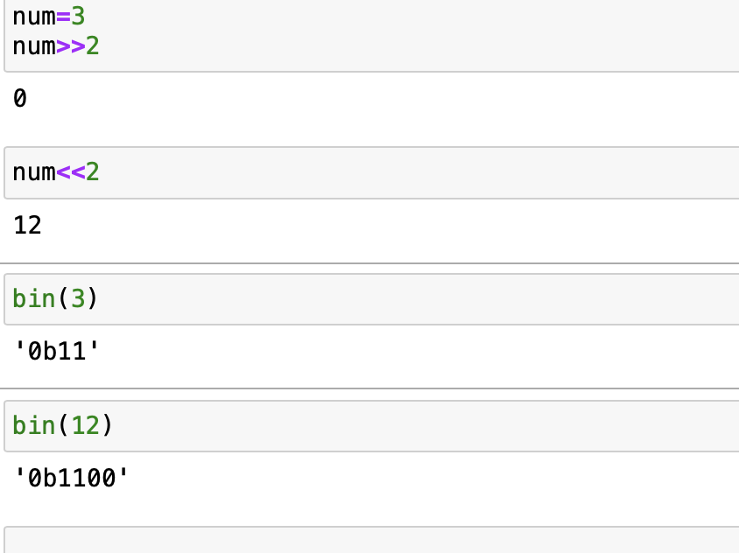Ans: The bitwise shift operators are the right-shift operator ( >> ), which moves the bits of an integer or enumeration type expression to the right, and the left-shift operator ( << ), which moves the bits to the left.

* 1. Create a list containing int type data of length 15. Then write a code to check if 10 is present in the list or not.

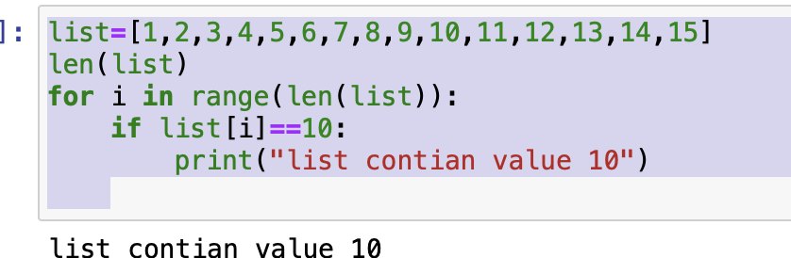Ans: